
HOPE FOR GIRLS AND WOMEN IN TANZANIA
P.O.BOX61, MUGUMU–SERENGETI, MARA - TANZANIA
E-Mail:hopeforgirlsandwomenserengeti@gmail.com
Website: https://hopeforgirlsandwomen.org
Twitter:@hopeforgirlsTZ Cell: +255 756 600 806

NARRATIVE REPORT, OCTOBER 2025:

INTRODUCTION:
Hope for girls and women Tanzania is an NGO which was registered legally at National level with its headquartering office at Mugumu–Serengeti District having a registration number 00NGO/0009414.

The Organization protests FGM, defends and advocates for girls’ and women rights against gender based violence and child marriage. We believe by providing education to girls and the community at large, we’re strengthening love and solidarity in the community, we shall create a community which is free from bad traditional ties, with dignity and development that will collectively declare an End to FGM, Child Marriage and other forms of Gender Based Violence. The organization has established Mugumu and Butiama Safe houses to protect girl’s fleeing from FGM and support young women who have experienced gender based violence from their families or community.

IMPLEMENTED ACTIVITIES

Hope for Girls and Women in Tanzania runs two safe houses in Serengeti and Butiama Districts to protect survivors from gender-based violence.
We also conduct community outreach in five districts; Serengeti, Butiama, Tarime, Rorya and Bunda but receive girls from different regions in the country.

Number of survivors protected at Mugumu Safe House
No. | Type of Case | Oct | Admission | Reconcile | Sept
1 | Fgm Cases | 58 | 0 | 0 | 58
2 | Child Marriage | 13 | 0 | 0 | 13
3 | Rape | 8 | 0 | 0 | 8
4 | Battery | 3 | 0 | 0 | 3
5 | Orphans-vulnerable children | 4 | 0 | 0 | 4
 | TOTAL | 86 | 0 | 0 | 86

NB:
- In the month of October, we started with the number of 86girls as shown on the table above.
- No admission took place this month or any reconciliation done at Mugumu safe house
- The number of children remained at our safe house in Mugumu is 86

Number of survivors protected at Butiama Safe House
No. | Type of Case | Oct | Admission | Reconcile | Sept
1 | Fgm Cases | 36 | 03 | 02 | 78
2 | Child Marriage | 11 | 00 | 00 | 08
3 | Rape | 14 | 01 | 00 | 05
4 | Battery | 03 | 01 | 01 | 01
5 | Orphans-vulnerable children | 01 | 00 | 00 | 01
 | TOTAL | 65 | 05 | 03 | 94

NB:
- Butiama Safe House, started the month of October with the total number of 68 girls as shown on the table above.
- 5 admission took place and 3 reconciliation was done during the month
- Currently we have 80 girls at Butiama Safe House.

Reconciliation:
During the month of October, Hope for Girls and Women in Tanzania in collaboration with social welfare Officers from Serengeti District, managed to conduct reconciliation session meetings with the parents of 3 girls, where by 2 cases were FGM cases and 1 was Battery case. During the meeting before reunification the parents were trained on parenting skills and understanding their children issues and supporting them so that they can remain at home and continued with their studies. The parents agreed to care for their children and fulfill their parental right.

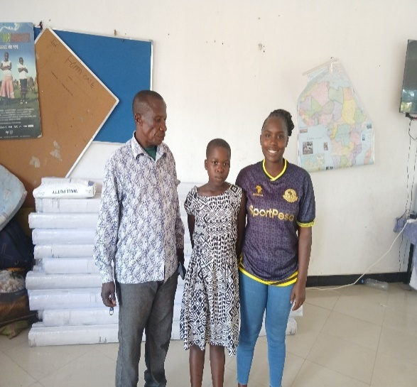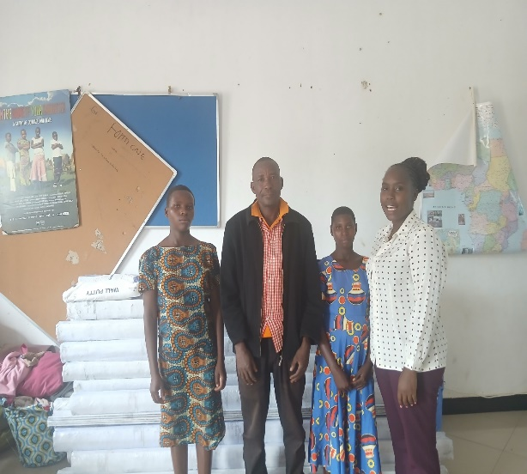Pictures taken during the reconciliation when the children were handed over to their parents

Admission:
In October 2025, in the collaboration with social welfare department and police gender desk, the Hope for Girls and Women in Tanzania managed to rescue 5 girls whereby 1girl had battery case, 1 girl was raped and 3 other girls were victims of FGM (they were brought to one of our safe house already circumcised and they need medication attention (post FGM treatment). All 5 girls still receive support in our shelter including medical checkup, post trauma counseling and psychosocial support.

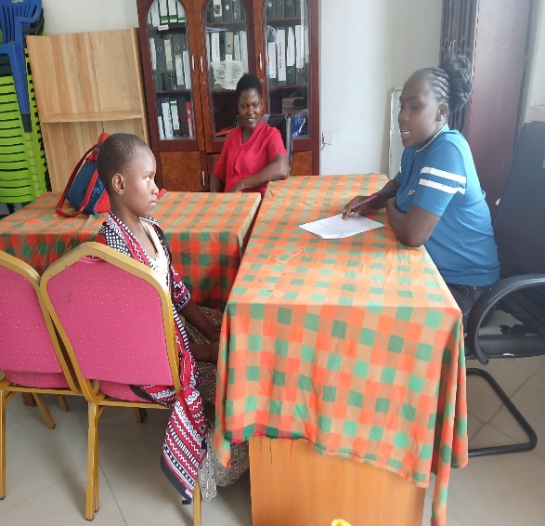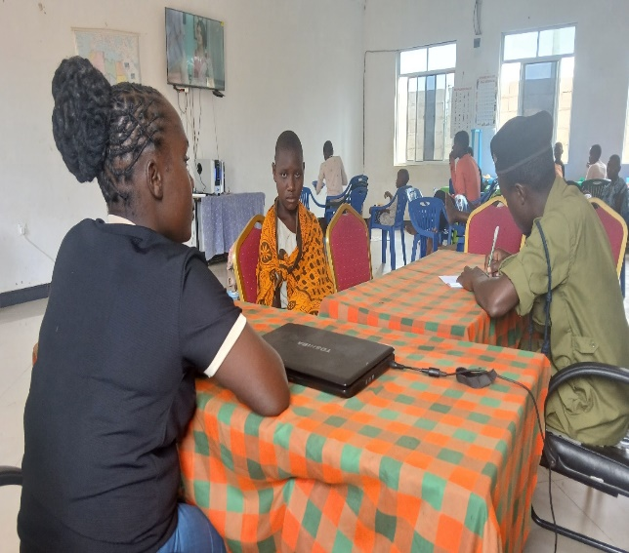These pictures shows admission activity in our safe house

Education:
Hope for Girls and Women in Tanzania continue to enabled girls to go to school for them to meet their bright future. We have girls in different levels includes primary level, secondary level, Vocational training and colleges and universities.

The organization has successfully managed to support the girls by providing them with basic needs including exercise books, pens, books, school attire and other important materials for sewing, gardening, beekeeping, chicken rearing, hand bags making, bracelets and knitting machines as tools to support them in their education both formal education, entrepreneurial and vocational skills.

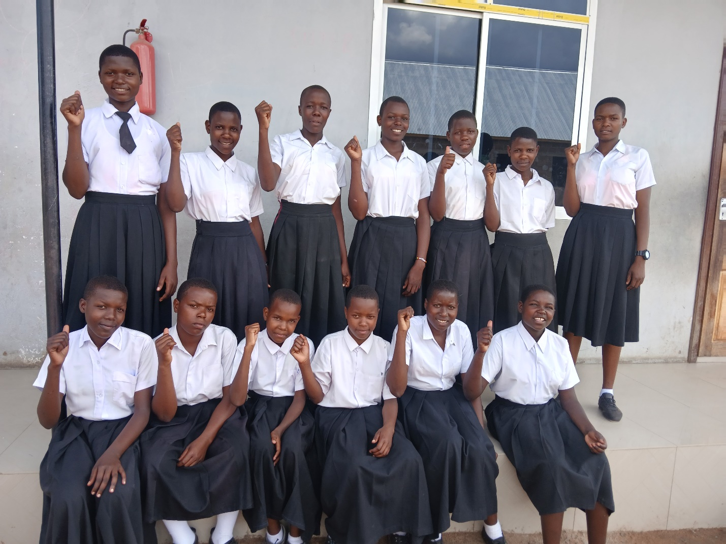Some of the secondary student in our Butiama Safe House

Some of the student in both primary level and secondary level at our Mugumu safe house

The table below shows the current total number of survivors supported in education at Mugumu and Butiama Safe Houses

Education Level | Mugumu | Butiama | Total
Below 5 years of age | 5 | 1 | 06
Reading, Counting and Writing | 8 | 2 | 10
Primary School–boarding | 3 | 0 | 03
Primary School–day | 21 | 28 | 49
Secondary School–boarding | 3 | 0 | 03
Secondary School–day | 25 | 17 | 42
Advance–Form5&6 | 2 | 0 | 03
Vocational Training Skill | 1 | 11 | 22
Tour Guide Course | 1 | 3 | 04
Hotel Management and Hospitality | 5 | 3 | 08
Community Development Course | 0 | 0 | 00
University | 0 | 0 | 00
Architecture Course | 0 | 0 | 00
Total | 74 | 65 | 139
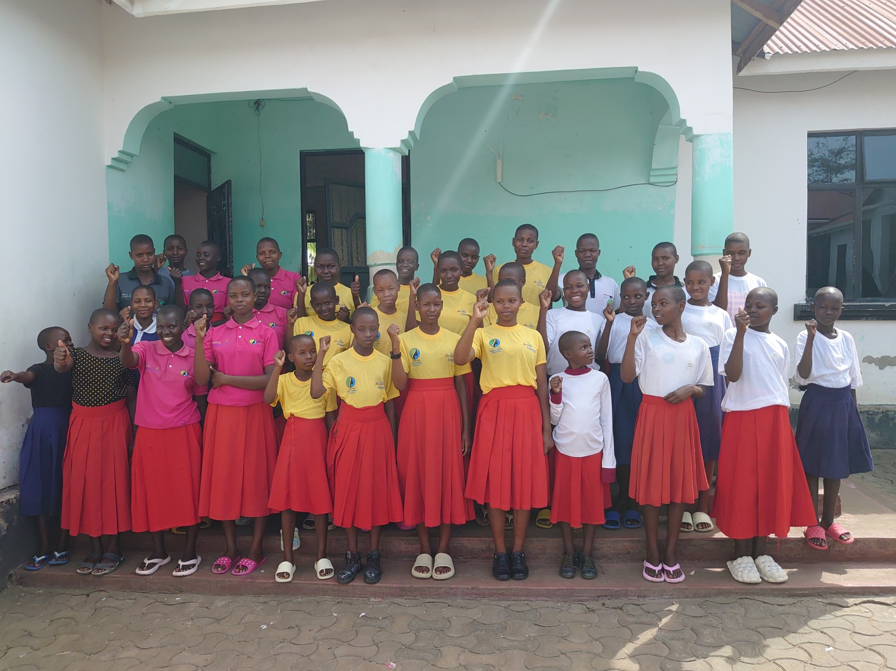
Some of survivors in our safe houses

Agriculture and Gardening:
In our Sayuni Garden during this month, we manage to teach the girls to know on how to cultivate and plant different types of vegetables by using organic (without using chemicals) while at the safe house when they return home, they will have the know-how to plant a small number of vegetables for consumption or sale by using natural thing (organic thing).And we managed to harvest tomatoes as the result of girls hard work.
- Planting fresh vegetables at our Sayuni Garden
- Planting spinach, African Nightshade, onion, collard and eggplant
List of the vegetables got from our garden.

No | Verities Vegetable | Amount in KG
1. | Spinach (mchicha ) | 10kg
2 | Collard green | 20kg
3. | Tomato | 80kg

Legal Issues:
Hope for Girls and Women in Tanzania has continued to collaborate with the Police Gender Desk Office and Social Welfare Office to ensure that they help girls who have passed through the acts of gender violence by cooperating with the courts to get their legal rights under the laws of the United Republic of Tanzania. The cases that were depending and still need evidence and testifying at court level has reduced from 14 cases to 3 cases, this is the huge step.

Cases in Progress at Mugumu and Butiama Safe Houses:

No of case | Type of case | Area | Police | At the court | Remark

7–Serengeti District | Child marriage–3 | Mugumu |  | 0 | Preliminary stage
7–Serengeti District | FGM–4 | Mugumu |  | 0 | Testifying at the court
7–Serengeti District | FGM–4 | Mugumu |  | 1 | Waiting for judgment
7–Serengeti District | Rape–0 | Mugumu |  | 0
7–ButiamaDistrict | Rape–7 | Kiabakari | 3 | 0 | Pending
7–ButiamaDistrict | Child marriage- 0 | Kiabakari | 0 | 0
7–ButiamaDistrict | FGM–0 | Kiabakari | 0 | 0 | Preliminary stage

Yoga and Sports:

In October 2025, we managed to conduct the total of 9Yoga sessions at Mugumu Safe House under the supervision of Hayley and her team through Zoom, the sessions helps the girls to be flexible, boost their brain power, better their immunity and help them to have good sleep.
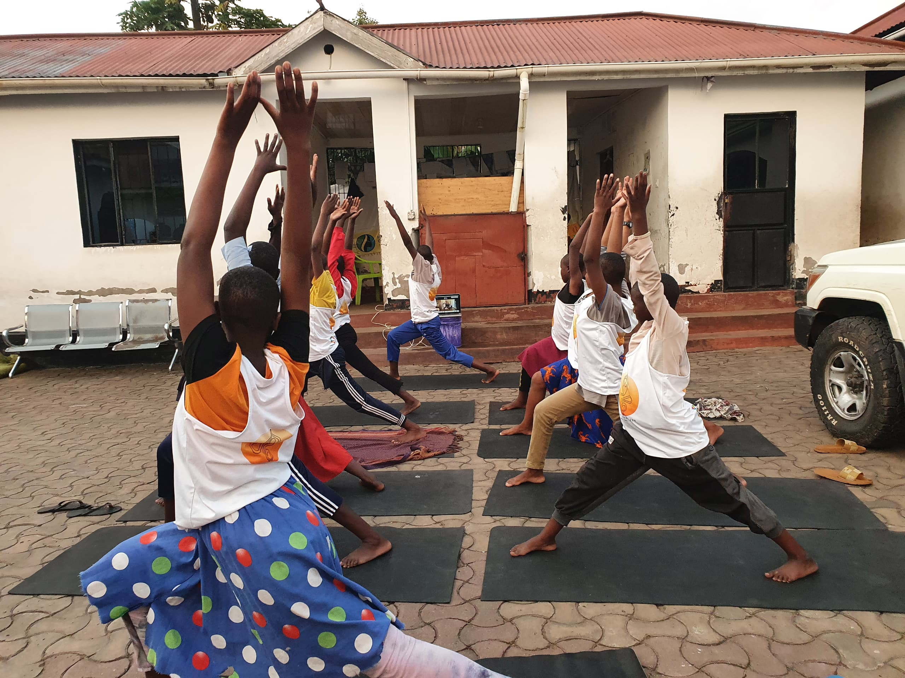
Yoga session

INHOUSE TRAINING

This October we conducted in house training for 76 girls at the Butiama Safe house, aimed at empowering them to understand their rights and responsibilities. The goal of this training was to help the girls realize that every right comes with a corresponding responsibility and that the two go hand in hand. At the end of the training, the girls had the opportunity to share their views on the positive aspects they have experienced as well as the challenges that needs to be addressed both among themselves and by the organization as the whole.

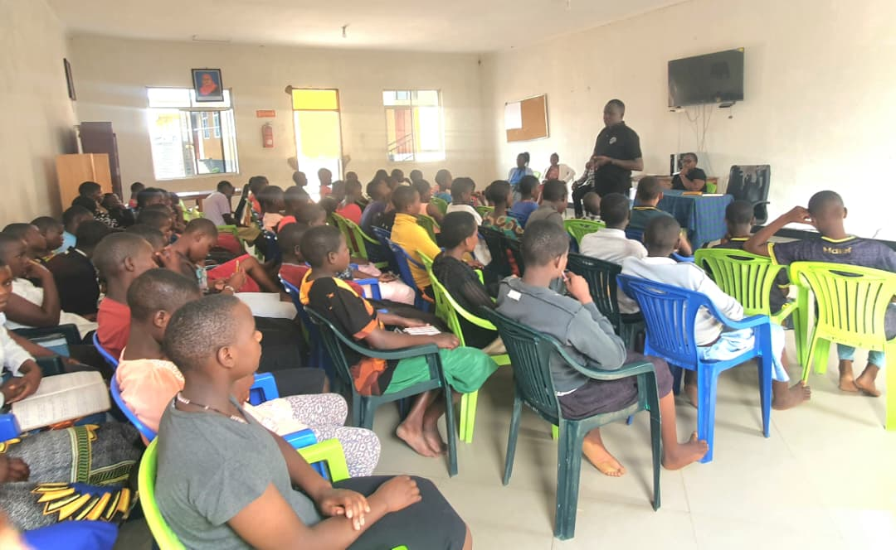Training photo that includes the girls and staff

OFFICIAL LAUNCH OF HOPE FOR GIRLS AND WOMEN IN TANZANIA BUTIAMA SAFE HOUSE FACILITIES

On the 19th of October 2025, Hope for Girls and Women in Tanzania in collaboration with various partners held a grand inauguration ceremony for new buildings at the Butiama safe house. The construction was funded y Polish AID in partnership with the Kiabakari Foundation. During the event, the organization officially opened an administration building, two classrooms, two workshops, a modern dining hall for children and staff equipped with modern kitchen and two full furnished dormitories (each dormitory accommodating 80 children, bringing the total capacity to 160 children at a time).
The guest of Honor at the inauguration was His Excellency Sergiusz Wolski, the Ambassador of Poland Tanzania. He was joined by the parish priest of Kiabakari parish (Fr. Voi), along with other distinguished guests including the District Commissioner of Butiama, the Resident Magistrate of Butiama, the officer commanding District (OCD) of Butiama. The officer commanding station (OCS) of Kiabakari, the head of prisons for Butiama District, local government leaders, partners, members of media, organization staff and children under our care.

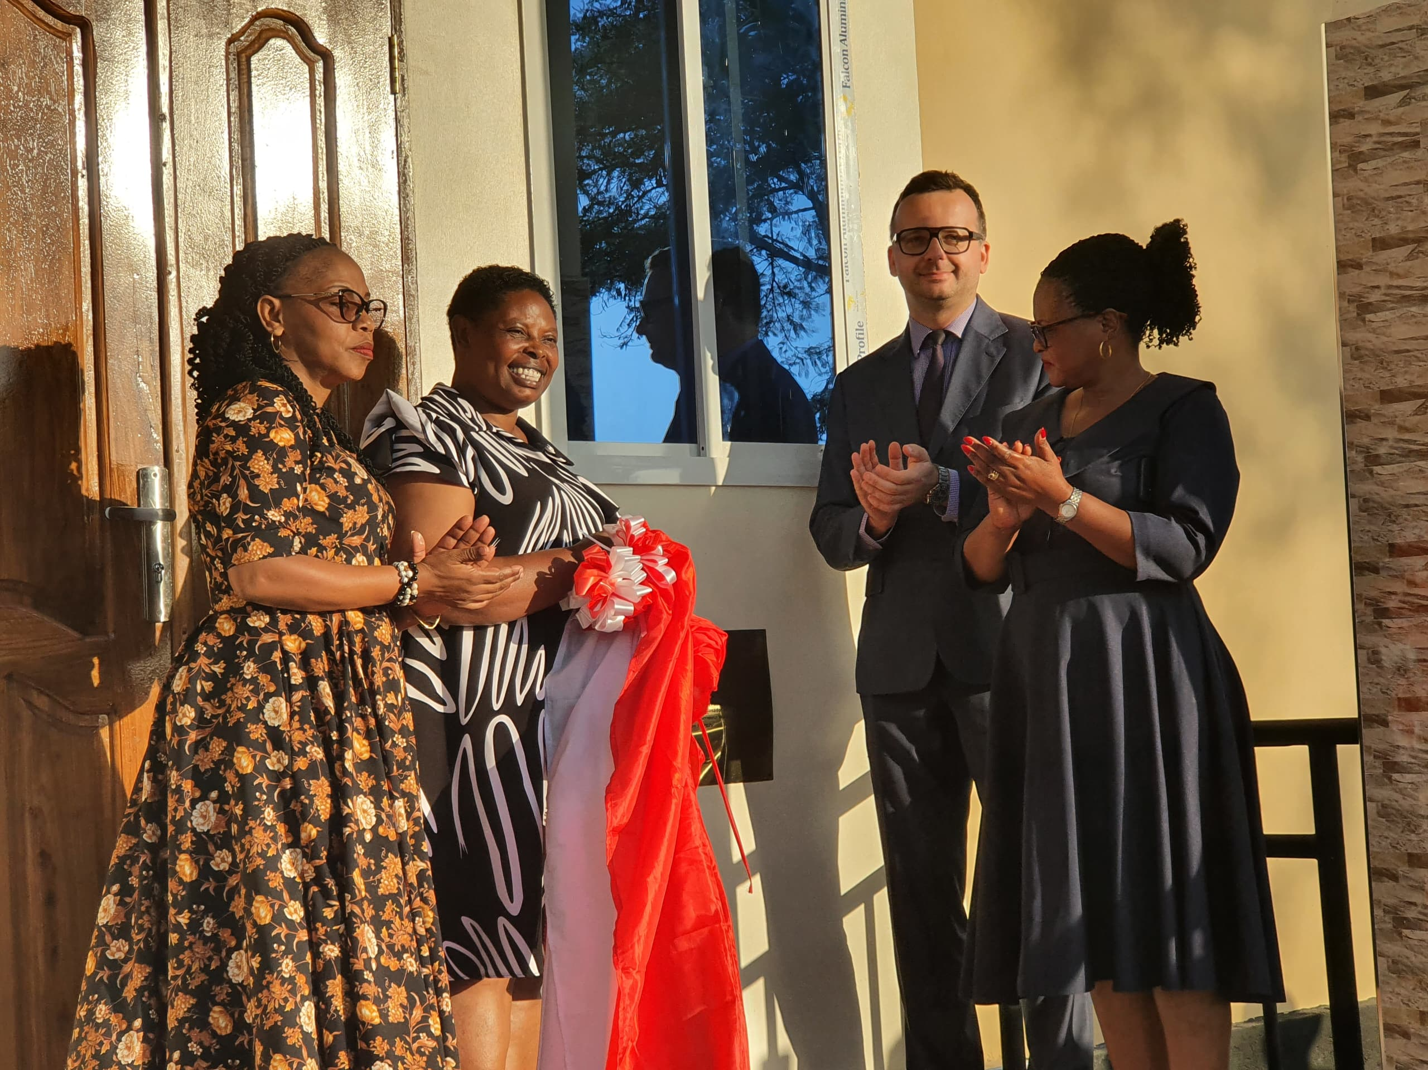This picture shows the ribbon cutting ceremony to mark the inauguration of the buildings

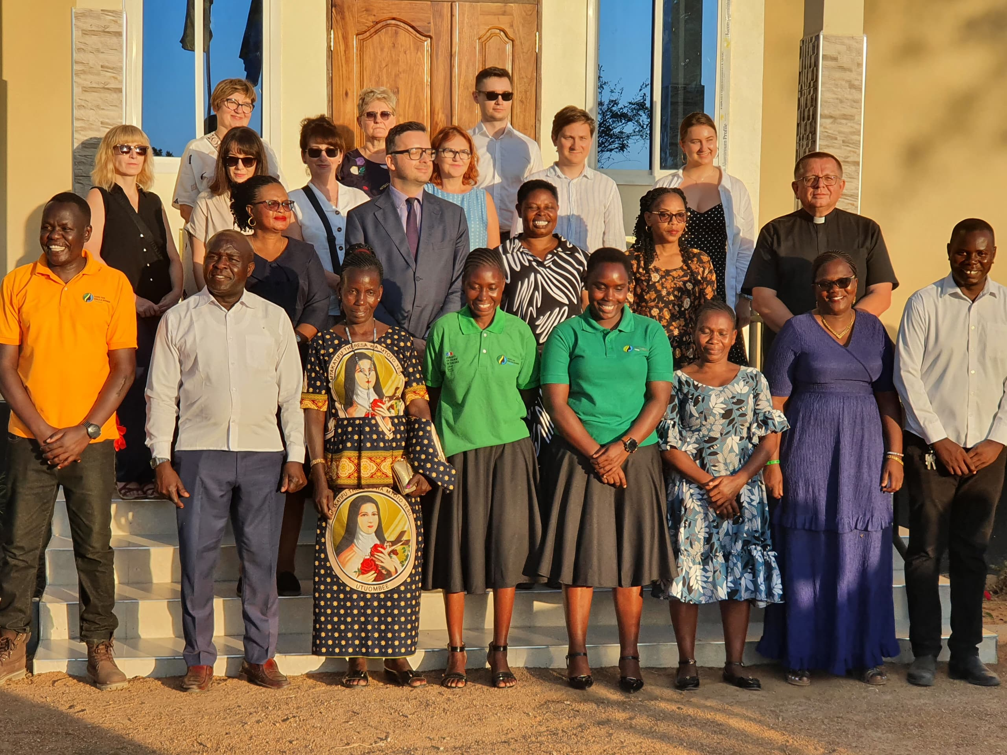This picture includes the guest of honor, the delegates who accompanied them and some of staff from HGWT
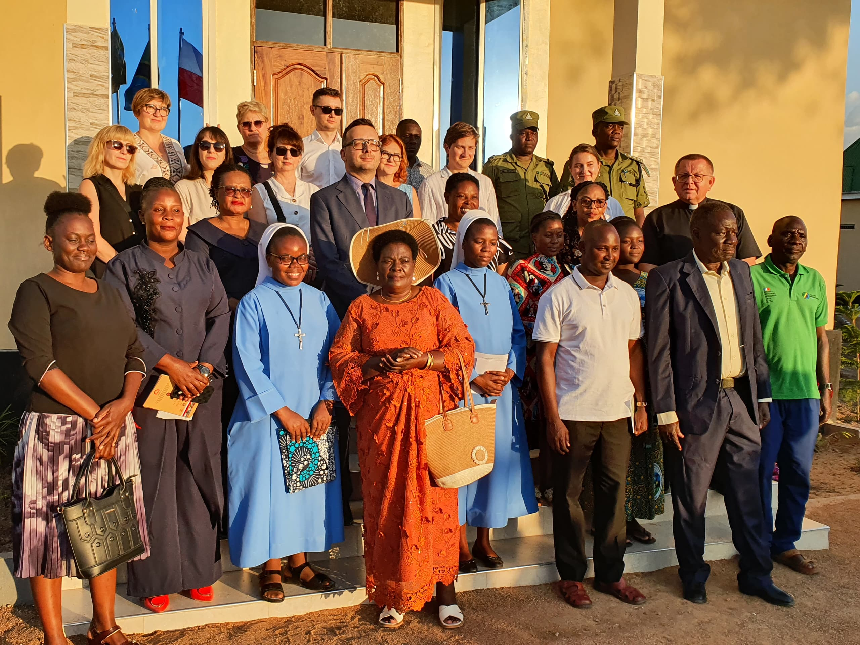This picture includes the guest of honor and various stakeholders including government leaders

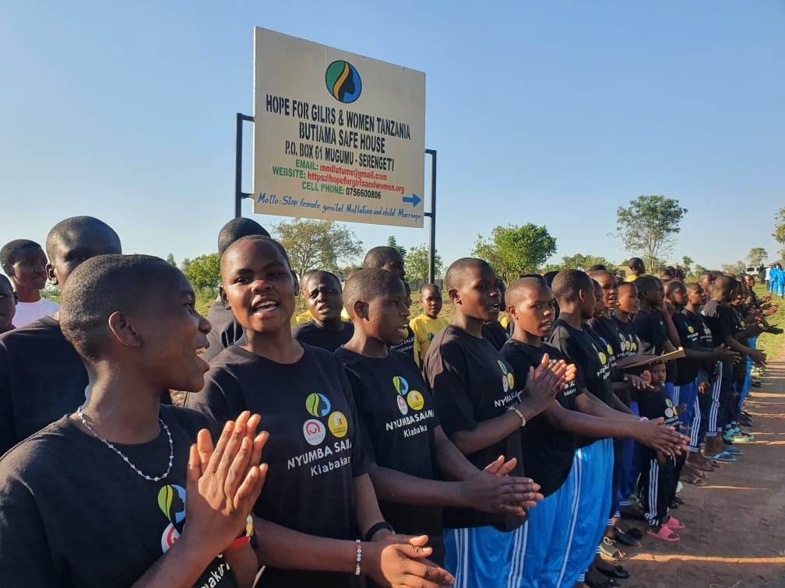This picture shows some of the girls resides at the safe house during the inauguration

CHALLENGES:

Safe houses running cost. HGWT is facing a major challenge in running the two safe houses which are now support 151 survivors of Gender based Violence as we do not have reliable and stable sources of fund to support our daily costs in our safe houses includes fund for basic needs such as food, medication, education, personal items and many other things related to children basic needs, currently we have 151girls in which 139 girls are supported in education in our two safe houses. This challenge hinders our work to support more children who need support.

- Rented safe house: In Mugumu we currently operate our safe house in an rented house, which is not enough to support more children especially during the cutting session where more children run to us for support and protection.
So, Hope for girls and Women in Tanzania needs to develop its own land at Serengeti District in order to have permanent buildings to accommodate 89 survivors who are currently protected at Safe house Mugumu, which will include the following;
- Strong Fence for Security purpose
- Hostels
- Administration block
- Staff quarters
- Means of transport

Support and donation from donors
In October, 2025 we received support and donation from different donors such as four seasons, Nomad and other individual donors, who supported us with some items as follows;
Donations received from Four Seasons at Mugumu safe House.
No | Item name | Quantity
1 | Maize Flour | 200kg
2 | Sugar | 25
3 | Cooking oil | 20 liters
4 | Pads | 24 pic
5 | Rice | 150
6 | Beans | 75
7 | Gas container | 80 kg
Donations received at Kiabakari Centre.

No | Item name | Quantity
1 | Sugar | 25kg
2 | Rice | 470 kg
3 | Beans | 392kg
4 | Soap | 8 boxes
5 | Colget | 13 dozen
6 | Cooking oil | 20 liters
7 | Firewood | 2 trips
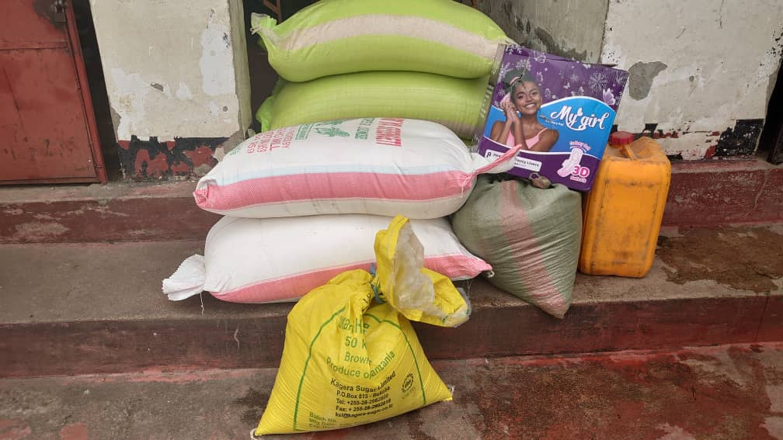Monthly donation from Four Season
This picture shows some of the Visitors from nomad UK provided with a overview of the organization at Mugumu Safe house
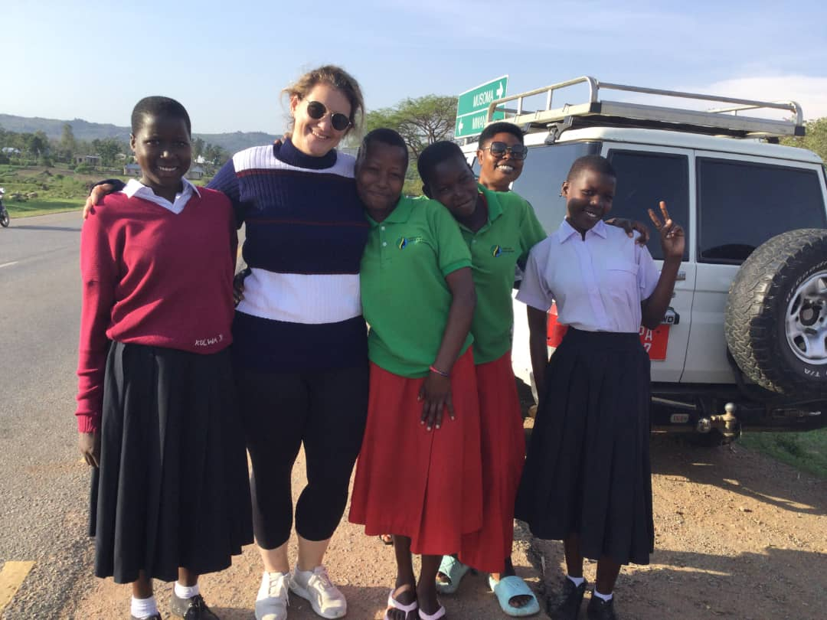The picture shows our girls and our Director smiling with the visitor who visited our Butiama safe house

CONCLUSION:
Hope for Girls and Women in Tanzania, would like to recognize, acknowledge and appreciate our partners, friends, individuals and donors for their much contributions towards our project.

Our special gratitude to;

- Tanzania Development Trust
- Four Seasons Hotels
- Fr. Voi
- Rup, Grace
- Lewis and Hayley
- Karin, Jean
- June Powell
- Netzwerk Rafael Ev
- Kirsten
- Roberta Roca’s family
- Polish AID
- Foundation Kiabakari
- Other individual donors and supporters.

Prepared by

Domina W. Mabebe
Assistant Director
Hope for Girls and Women in Tanzania


Checked and Approved by
RhobiSamwelly

Chief Executive Director
Hopefor GirlsandWomeninTanzania.

